**EXPERIMENT – 23 SOFTWARE AS A PRODUCT**

**AIM:**

To demonstrate Storage as a Service (SaaS) by creating and configuring a

new VM image in Azure.

**PROCEDURE:**

1. Log in to the Azure Portal.

2. Click on Virtual Machines and then click + Create to launch the Create

a virtual machine wizard.

3. Fill in basic details such as subscription, resource group, VM name, and

region.

4. Choose an image (e.g., Ubuntu Server or Windows Server) and configure

the size according to requirements.

5. Set the administrator username and password or SSH key for access.

6. In the Disks section, configure the OS disk type and optionally attach

additional data disks.

7. Under the Networking section, configure the virtual network, subnet, and

public IP if needed.

8. Click Review + Create and then Create to deploy the VM.

9. After deployment, go to the VM’s Settings → Disks to manage and

confirm the attached storage.

10.Verify that the storage service is active by logging into the VM and

checking the mounted volumes.

**OUTPUT:**

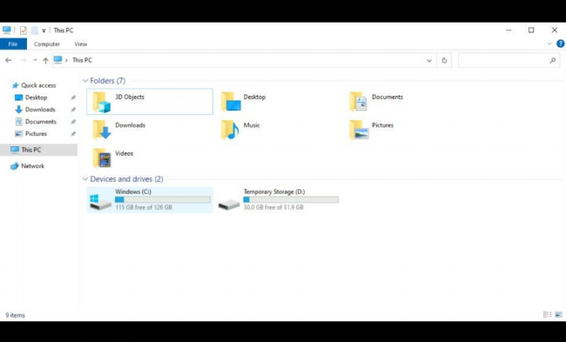

**RESULT:**

Successfully demonstrated Storage as a Service (SaaS) by configuring a new VM image and verifying attached storage in Azure.